

Freedom of Information Act Policy

Created: 8/19/14 | Updated: 8/20/25, 1/27/26

A brief description of our public body is as follows:

A. The mission of the Peoria Public Library is to provide all residents books, other printed materials, new technologies, and programs that stimulate personal intellectual growth and development, and provide a satisfying experience that nurtures a love of reading and the joy of discovery.

B. An organizational chart is attached.

C. The total amount of our operating budget for FY2025 is $9,308,961.

Funding sources are property and personal property replacement taxes, state and federal grants, fines, charges, and donations.

D. The office is located at this address:

Peoria Public Library, 107 Northeast Monroe, Peoria IL 61602

It has branch locations at:

Lakeview Branch, 1137 West Lake, Peoria IL 61614
Lincoln Branch, 312 West Lincoln, Peoria IL 61605
McClure Branch, 315 West McClure, Peoria IL 61604
North Branch, 3001 West Grand Parkway, Peoria IL 61615

E. We have approximately the following number of persons employed:

Full-time 73
Part-time 19

F. The following organization exercises control over our policies and procedures: The Peoria Public Library Board of Trustees, which meets monthly on the third Tuesday of each month, 5:30 p.m., at the library.

Its members are: Ruth Bittner, President; Steve Marx, Vice President; Roberta Parks, Secretary; Cecilia Buckner, Margaret Cousin, Scot Driscoll; Kevin Kinne; Jacob Roberts; and Barbara Van Auken.

G. We are required to report and be answerable for our operations to:
Illinois State Library, Springfield, Illinois. Its members are: State Librarian, Alexi Giannoulias (State Librarian); Director of State Library, Greg McCormick; and various other staff.

You may request the information and the records available to the public in the following manner:

A. Send the attached request form (see attached) in person, by mail to the Main library address, or by email to the FOIA officer email address below.

B. Your request should be directed to the following individuals:

Randall Yelverton, FOIA officer (RandallYelverton@ppl.peoria.lib.il.us) or Veronica De Fazio, FOIA officer (VeronicaDeFazio@ppl.peoria.lib.il.us)

C. You must indicate whether you have a “commercial purpose” in your request.

D. You must specify the records requested to be disclosed for inspection or to be copied. If you desire that any records be certified, you must specify which ones.

E. To reimburse us our actual costs for reproducing and certifying (if requested) the records you will be charged the following fees:
- There is a $1.00 charge for each certification of records.
- There is no charge for the first fifty (50) pages of black and white text either letter or legal size.
- There is a $.15 per page charge for copied records in excess of 50 pages.
- The actual copying cost of color copies and other sized copies will be charged.
F. If the records are kept in electronic format, you may request a specific format and if feasible, they will be so provided, but if not, they will be provided either in the electronic format in which they are kept (and you would be required to pay the actual cost of the medium only, i.e. disc, memory stick, etc.) or in paper as you select.

G. All requests must be in written form. The office will respond to a written request within five (5) business days or sooner if possible. An extension of an additional five (5) business days may be necessary to properly respond. A “business day” is a regular day of the week (Monday through Friday) when public offices and most businesses are open. Saturdays, Sunday and legal
holidays are not business days and cannot be counted in the five (5) business day time period.

H. Records may be inspected or copied. If inspected, an employee must be present
throughout the inspection.

I. The place and times where the records will be available, by appointment, are as follows:
Monday – Friday 9:00 a.m. to 5:00 p.m. Peoria Public Library Administrative Offices.

J. Certain types of information maintained by us are exempt from inspection and copying per the Library Confidentiality Act (75 ILCS 70/71). However, the following types or categories of records are available for public inspection:
- Monthly Financial Statements
- Annual Receipts and Disbursements Reports
- Budget and Appropriation Ordinances
- Levy Ordinances
- Operating Budgets
- Annual Audits
- Minutes of the Library Board of Trustees
- Library Policies, including Materials Selection
- Adopted Ordinances and Resolutions of the Board
- Annual Reports to the Illinois State Library

For more information on the Illinois Freedom of Information Act, visit the website posted by the Illinois Attorney General at http://illinoisattorneygeneral.gov/Open-and-Honest-Government/PAC/

The Freedom of Information Act Policy will be reviewed and revised as necessary by the Board of Trustees of Peoria Public Library.

Adopted by the Peoria Public Library Board of Trustees on MONTH DATE, YEAR. Budget, staff, and Board member information is updated as changes necessitate.

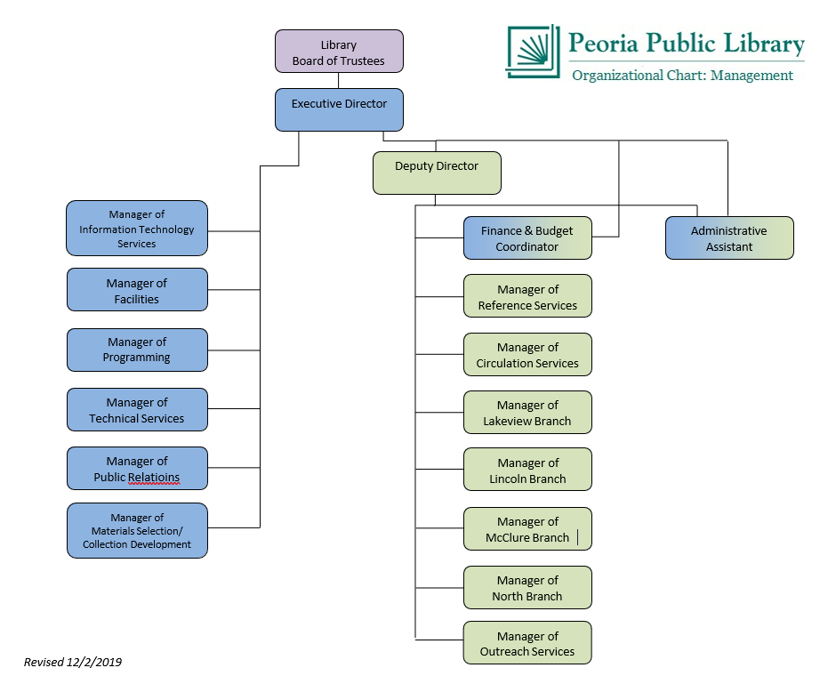

FOIA Request Form
Requestor’s Name (or business name, if applicable) |  |  |  | Date of Request | Phone number
Street Address |  |  |  | Certification requested:  _ _ Yes _ _ No
City State Zip
Description of Records Requested:

Is the reason for this request a “commercial purpose” as defined in the Act? _ Yes _ No
Library Response (Requestor does not fill in below this line)
A P P R O V E  D |  |  | ) The documents requested are enclosed.  ) You may inspect the records at
A P P R O V E  D | on the date of .  The documents will be made available upon payment of copying costs of  $ .  ) For “commercial requests” only: the estimated time of when the documents will be available is , at the prepaid costs stated above.
D E N I E D | ) The request creates an undue burden on the public body in accordance with Section 3(g) of the Freedom of Information Act, and we are unable to negotiate a more reasonable request.  ) The materials requested are exempt under Section 7 of the Freedom of Information Act for the following reasons:  Individual(s) that determined request to be denied and title:  In the event of a denial, you have the right to seek review by the Public Access Counselor at (217) 558-0486 or 500 S. Second St., Springfield, IL 62705  or you have the right to judicial review under Section 11 of FOIA.  ) Request delayed, for the following reasons (in accordance with 3(e) of the FOIA): . You will be notified by the date of as to the action taken on your request.
NOTE: This form cannot be MANDATORY under FOIA, but it is preferred. Failure to use it may result in the request not being properly or promptly processed.
(
(
(
(
FOIA Officer | Date of Reply

